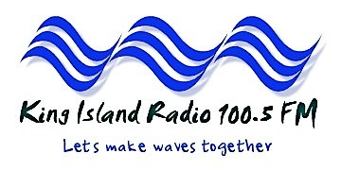

Let’s make some waves together

APPLICATION FOR MEMBERSHIP 2023/2024
King Island Community Radio Incorporated
ABN 45183557243

Email: kicomradio@gmail.com
www.kingislandradio.com
www.facebook.com/KingIslandRadio
Mob: 0438875560

Thank you for your interest in keeping King Island Radio 100.5 FM on the air by supporting us with your membership.
Should you wish to speak to someone about your membership, please phone Christine McLennan on 0402 138 285
Please choose your membership type (tick the appropriate box below), and enclose a cheque, or
direct debit
BSB 037 602
account no 17 1965

Type | Tick | Annual Cost | Notes
Single Concession*: |  | $10
Single |  | $15
Family: |  | $20
* full-time students, health care card holders and aged pensioners

Name:
PO Box:
Address:
Postcode: 7256
email:

Phone

Signed: ______ ___________________ Date: ______________

This membership will expire on 30 August 2021

www.kingislandradio.com or www.facebook.com/KingIslandRadio
Thank you again for your support!

